Python Libraries Lab

University Mohammed VI Polytechnic
College of Computing
Professor: Fahd KALLOUBI
Course: CS3 - MLOps
Academic Year: 2025/2026
Submission Date: November 2025
MAHMOUD MAFTAH

INTRODUCTION:
This lab report covers the practical implementation of Pytest, Pydantic, and FastAPI for moving machine learning models from research to production.

1. Introduction to Pytest

1.1 Basic Testing

Implementation:
- Created my_module.py with a square(x) function
- Implemented test_my_module.py with basic assertions
- Pytest automatically detected files starting with test_
- Verified test failures by changing expected values

Key Observations:
- Pytest discovers tests automatically without configuration
- Clear failure messages improve debugging
- Test files must follow naming convention (test_*.py)

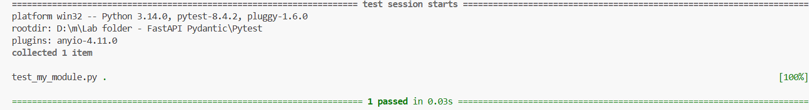
First test:

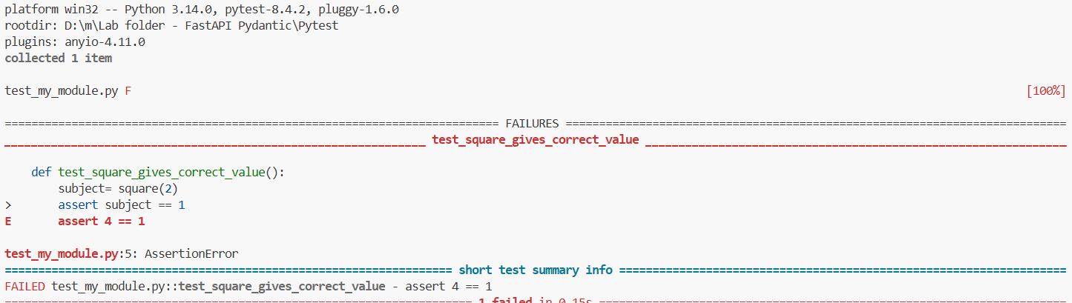
After changing value 4 to 7:

1.2 Fixtures
Objective: Use fixtures to share setup code across tests.

Implementation:
- Created fixtures with @pytest.fixture decorator
- Implemented input_value() fixture returning test data
- Used fixtures as function parameters in test functions
- Centralized fixtures in conftest.py for reusability

Key Benefits:
- Eliminates code duplication across tests
- conftest.py makes fixtures available to all test files
- Cleaner test code with separation of setup and assertions

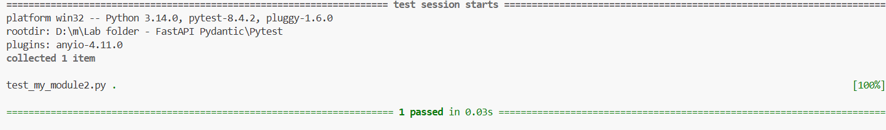
After using fixture:

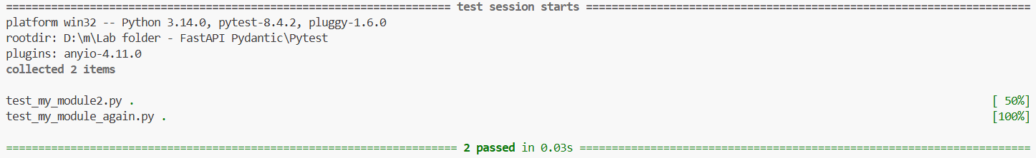
After adding another test:

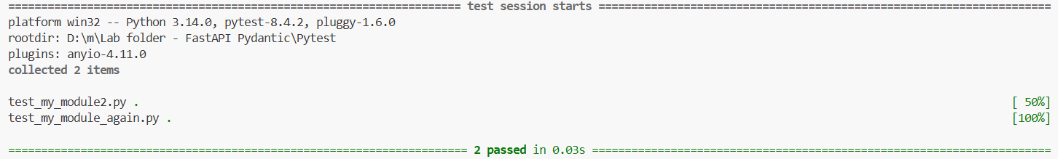
Using conftest.py:

1.3 Parametrized Tests
Objective: Test multiple inputs with single test function.

Implementation:
- Used @pytest.mark.parametrize decorator
- Tested multiple values [2, 3, 4] with one test function
- Each parameter generated a separate test case

Results:
- Converted 1 test function into 3 executed tests
- Efficient way to test multiple scenarios
- Total tests increased from 2 to 4 in the suite

Paramaterized test:

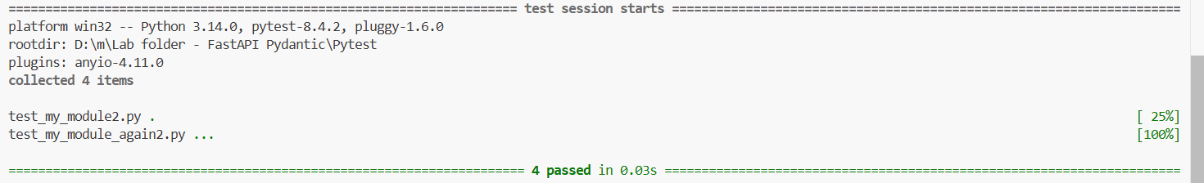

2. Data Validation with Pydantic

2.1 Basic Models
Objective: Understand Pydantic's data validation and type coercion.

Implementation:
- Created User model inheriting from BaseModel
- Defined fields with type annotations (int, str, List, Optional)
- Tested automatic type conversion (string '123' → integer 123)
- Verified datetime parsing from string format

Key Observations:
- Mandatory fields require type annotations without defaults
- Optional fields accept None or use default values
- Automatic type coercion when possible
- ValidationError raised for invalid data (e.g., non-numeric strings for int fields)

2.2 Recursive Models
Objective: Create complex nested data structures.

Implementation:
- Created nested models (Foo, Bar, Spam)
- Used models as types within other models
- Demonstrated composition with lists of model instances
Result: Successfully validated complex hierarchical data structures, proving Pydantic's capability for real-world API schemas.

Example 1:

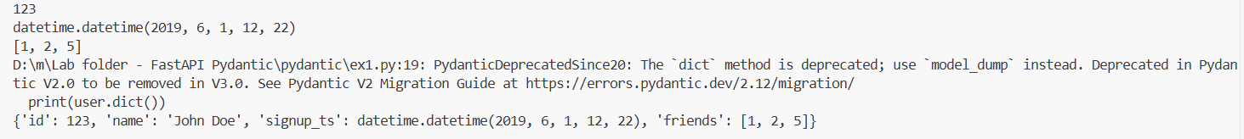
Types were converted for id '123' string to int 123, '5' string to int 5, signup_ts string to datetime

Example 2:

2.3 Custom Validators
Objective: Implement business logic validation rules.

Implementation:
- Created UserModel with password matching validation
- Implemented validators for:
  - Name format (must contain space)
  - Username format (alphanumeric only)
  - Password confirmation matching

Key Features:
- @validator decorator for field validation
- Access to other field values via values parameter
- Clear error messages for validation failures
- Validators can transform data (e.g., .title() for names)

Validator:
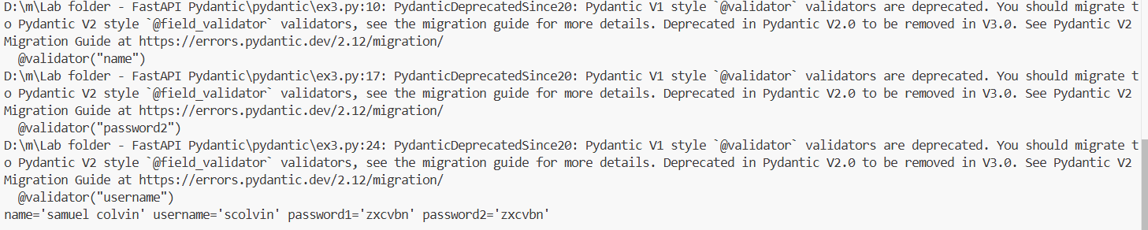

3. Building APIs with FastAPI

3.1 Introduction to FastAPI

Advantages over Flask:
- Built-in data validation via Pydantic
- Automatic API documentation (Swagger UI)
- Asynchronous support with ASGI server
- Type hints for better IDE support and error detection
- Production-ready with minimal configuration

JSON RESPONSE FROM LINK
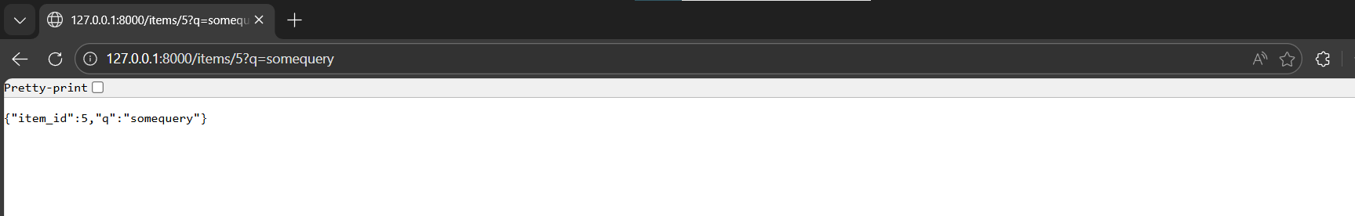

VALIDATION ERRORS
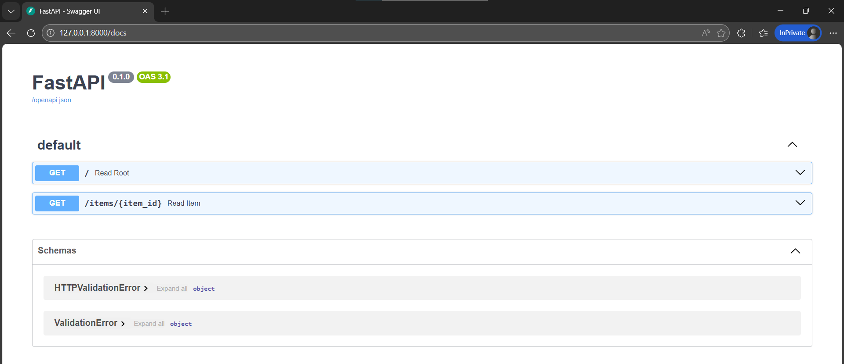

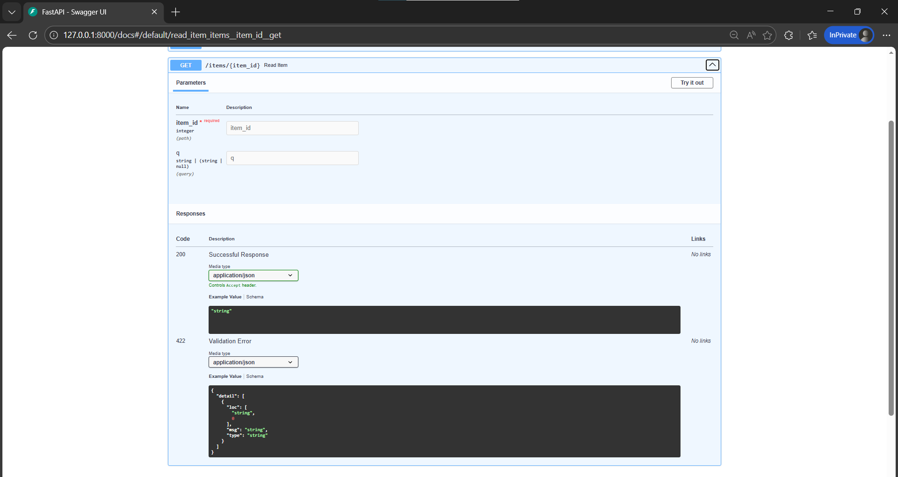
TEST AFTER ID CHANGE

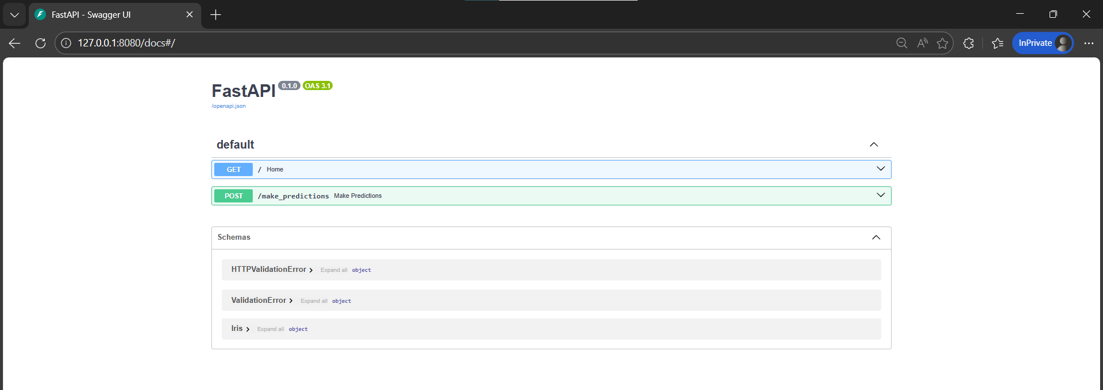

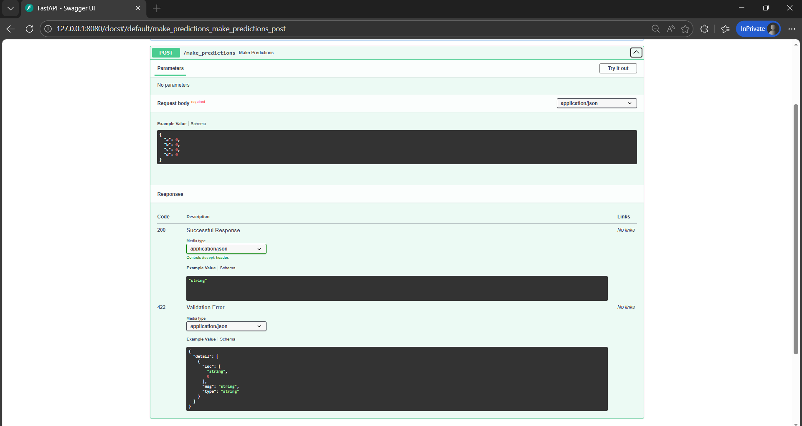

EXPLORING AVAILABLE PREDICTION UIs:
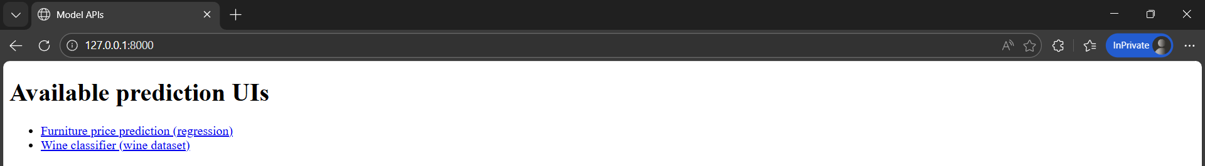

TESTING THE FURNITURE PREDICTION:
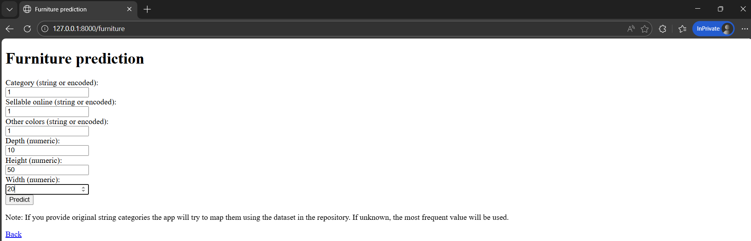

FURNITURE PREDICTION RESULTS:
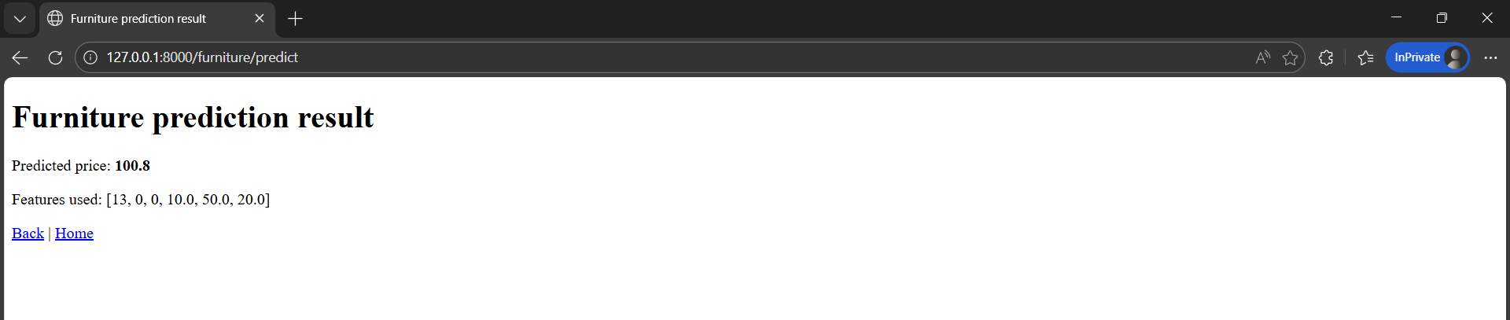

WINE CLASSIFIER TEST FROM THE SET OF SELECTED FEATURES
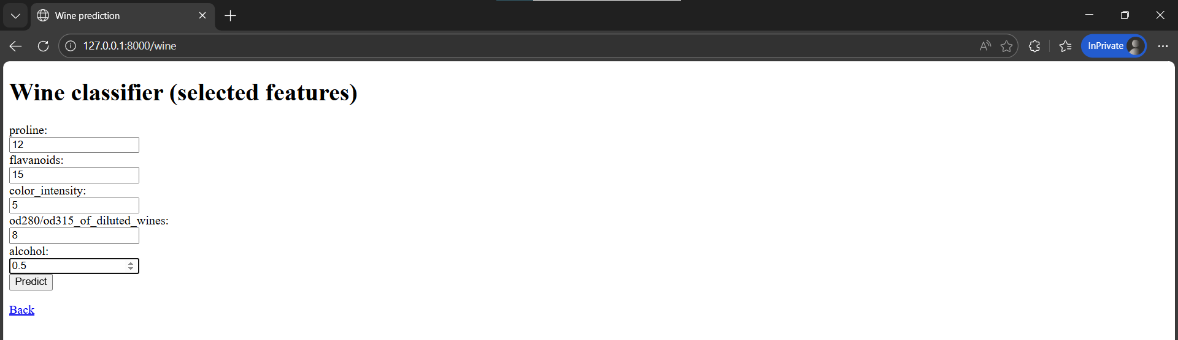

WINE PREDICTION RESULTS
